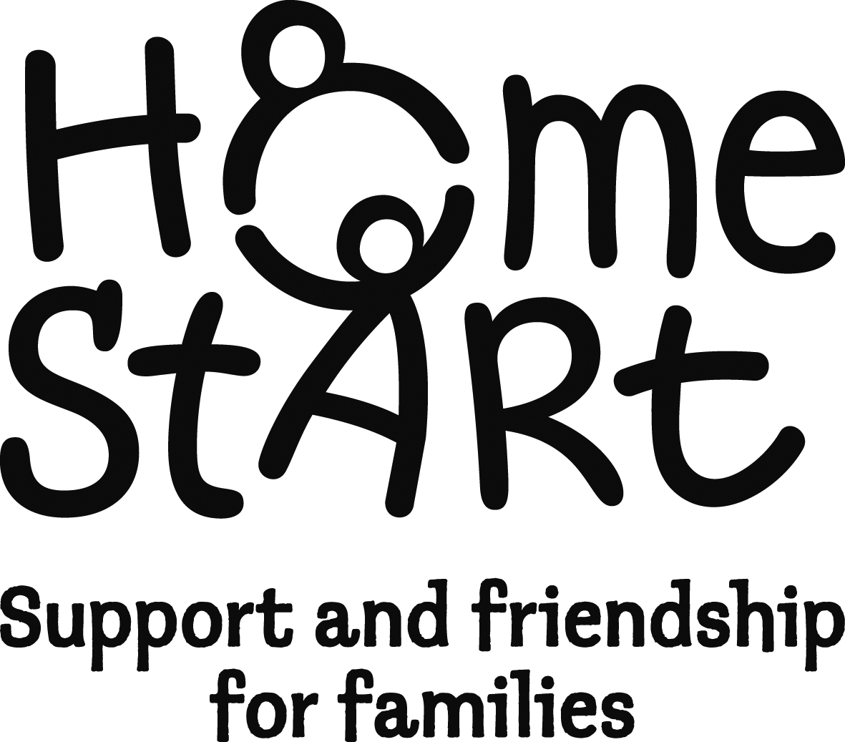
Description of the work of a
Home-Start East Fife Family Support Group Volunteer

Family Support Group provides a safe environment in which families can come together and share the daily challenges of family life. A variety of projects and activities are run to help families make the most of family life: they encourage the families to play and have fun together within their own family as well as with the wider group and promote self-confidence and positive parenting. Home-Start East Fife (HSEF) volunteers play a vital role.

Title: Home-Start Family Support Group Volunteer
This work requires a level of commitment and reliability and will be supported by Home-Start East Fife staff.

Responsible to: The Home-Start Project Worker, who is in turn responsible to the Senior Co-ordinator. The Project Worker is responsible for the smooth running of the Family Support Groups and oversees the Family Support Group volunteers and the tasks they carry out whilst they are at the group.

Purpose of the Family Support Groups

The families that attend Home-Start East Fife Family Support Group do so for a variety
of reasons that often make it difficult for them to access mainstream groups. A very common problem, for example, is parents’ social isolation. This problem can be created
and compounded by several factors, such as low self-esteem, lack of confidence and poor parenting skills.

The purpose of the group is to help the families to address these issues and in so doing ultimately benefit the children and the family as a whole. In order to achieve this, Home-Start East Fife Family Support Group volunteers are expected to:

- offer support and friendship to the families;

- reassure families that their difficulties in bringing up children are not unusual;

- emphasise the positive aspects of family life;

- encourage parents’ strengths and emotional well-being for the ultimate
benefit of their children;

- ensure a safe, fun group for both children and adults;

- become involved in the various activities and projects, from concept to implementation (ideas new or old are always welcome) and encourage the families to do so as well;

- encourage families to become involved in the running of the group.

PTO
Hours of work

- It is not essential to attend a Preparation Course, but it would be useful and the initial course of preparation normally lasts approximately 40 hours over a number of weeks.
The courses are usually run bi-annually, one in the Spring and one in the Autumn.

- The duration of each Family Support Group is two hours, however, the setting out and putting away of toys requires some additional time so a minimum of two and a half hours per week is required.

- It is helpful for the families to build a rapport with volunteers so ideally a regular weekly commitment of one year or more is required (please note that the group runs during school term time only).

Role

- To be familiar with and committed to the Home-Start East Fife ethos as specified
in the Constitution, Memorandum and Articles of Association, the Standards and
Methods of Practice, the Home-Start Agreement and the Home-Start Policy
and Practice Guide.

- To understand, agree to and implement Home-Start’s policies on:
- confidentiality;
- equal opportunities;
- child protection;
- health & safety.

- To be introduced to the families who attend Family Support Group, to welcome new families and to get to know families as appropriate/relevant.

- To share relevant information about HSEF families with the Project Worker and to contact the Project Worker or a Co-ordinator immediately if there is any concern about the physical or emotional well being of any member of the group.

- To take part in the group planning meetings, Volunteer Group Meetings and training sessions as arranged by the scheme.

- To help with all aspects of the general running of the group: this will include such duties as the preparation of snack, setting up, registration, paying expenses to families, etc.

This is an exciting and rewarding volunteering opportunity, which requires energy, commitment, reliability, creativity, and a sense of humour. All volunteers can expect the support of Home-Start East Fife staff, other volunteers and the Board of Trustees.

